Create a simple cloud software application for Library book reservation system for SIMATS library using any Cloud Service Provider to demonstrate SaaS.
AIM
To design and develop a Library Book Reservation System for SIMATS Library using Zoho Creator as a cloud service provider and demonstrate the concept of Software as a Service (SaaS).
PROCEDURE
- Login to www.zoho.com using a valid Zoho account.
- Open Zoho Creator and click Create Application.
- Select Create from Scratch.
- Enter the application name as SIMATS Library Book Reservation System.
- Create a form named Library Book Reservation Form.
- Add the following fields in the form:
  - Student Name
  - Register Number
  - Department
  - Year of Study
  - Mobile Number
  - Email ID
  - Book Title
  - Author Name
  - Book ID
  - Category
  - Availability Status
  - Date of Reservation
  - Return Date
  - Type of Issue
- Arrange the fields properly in the form.
- Save the form and publish the application.
- Provide access to users for submitting book reservation requests.
- Test the application by entering sample data.
Output
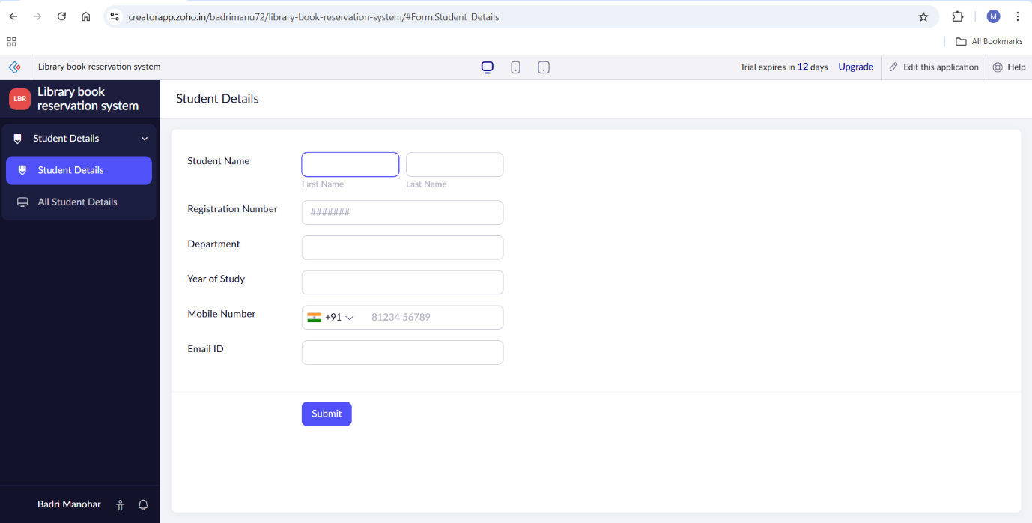
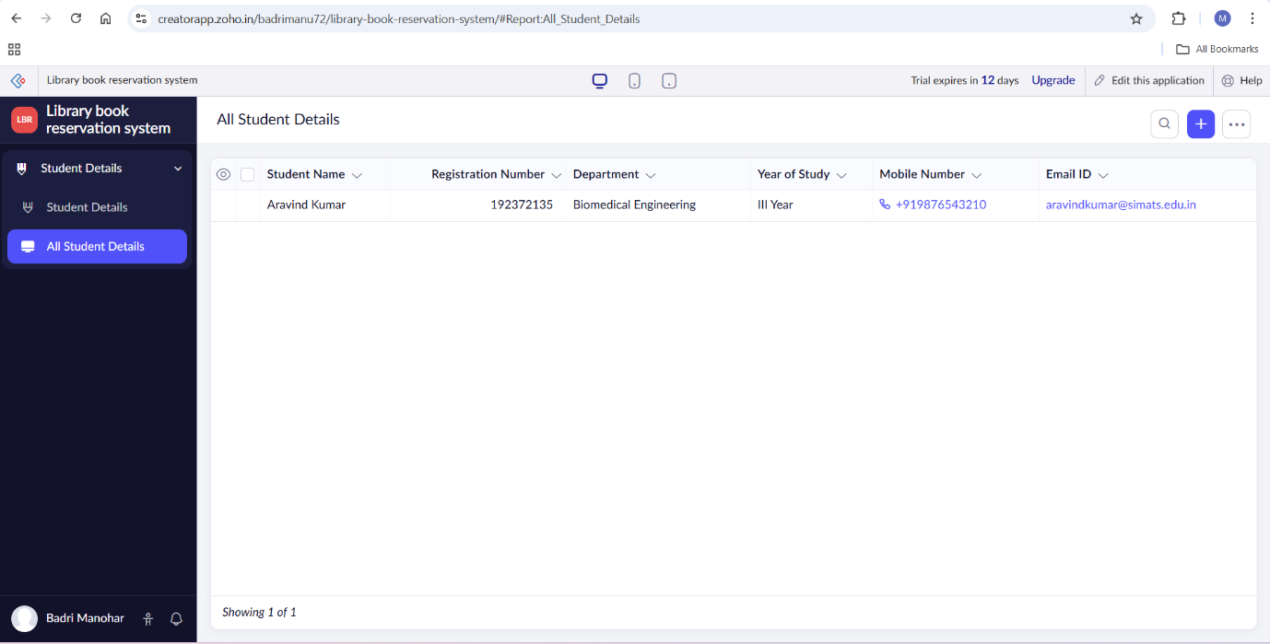
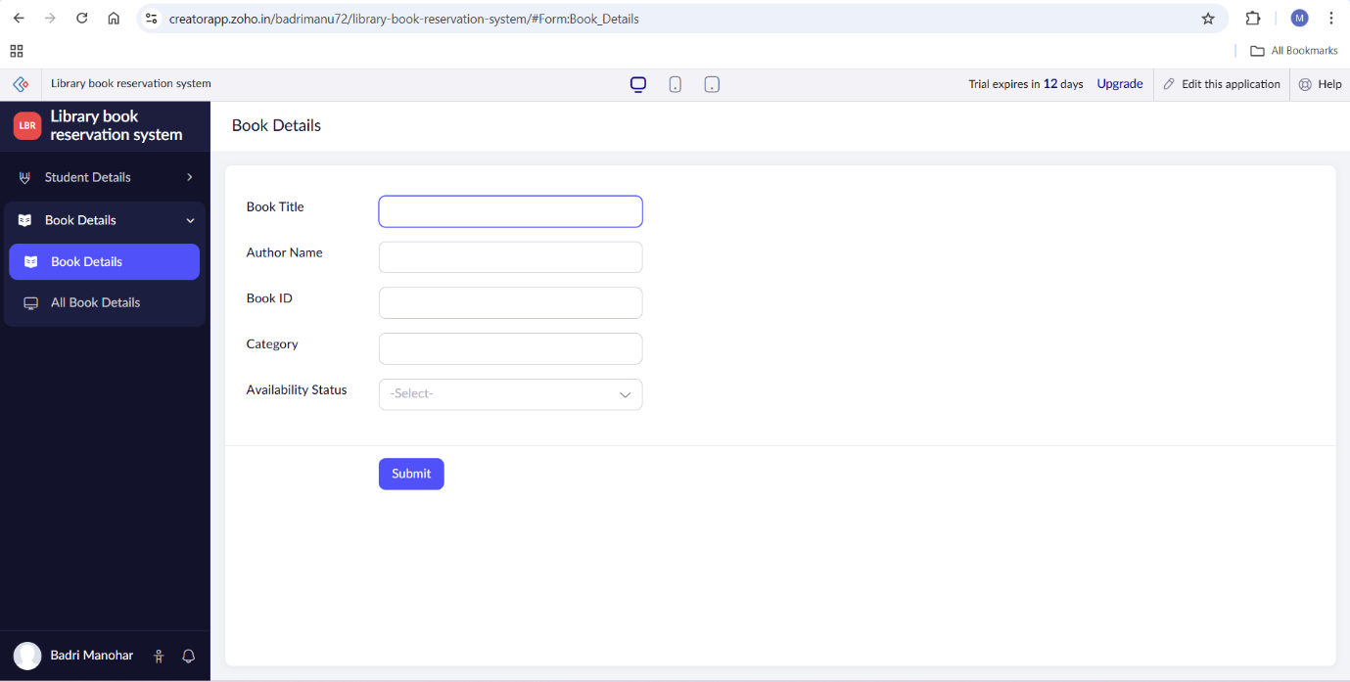
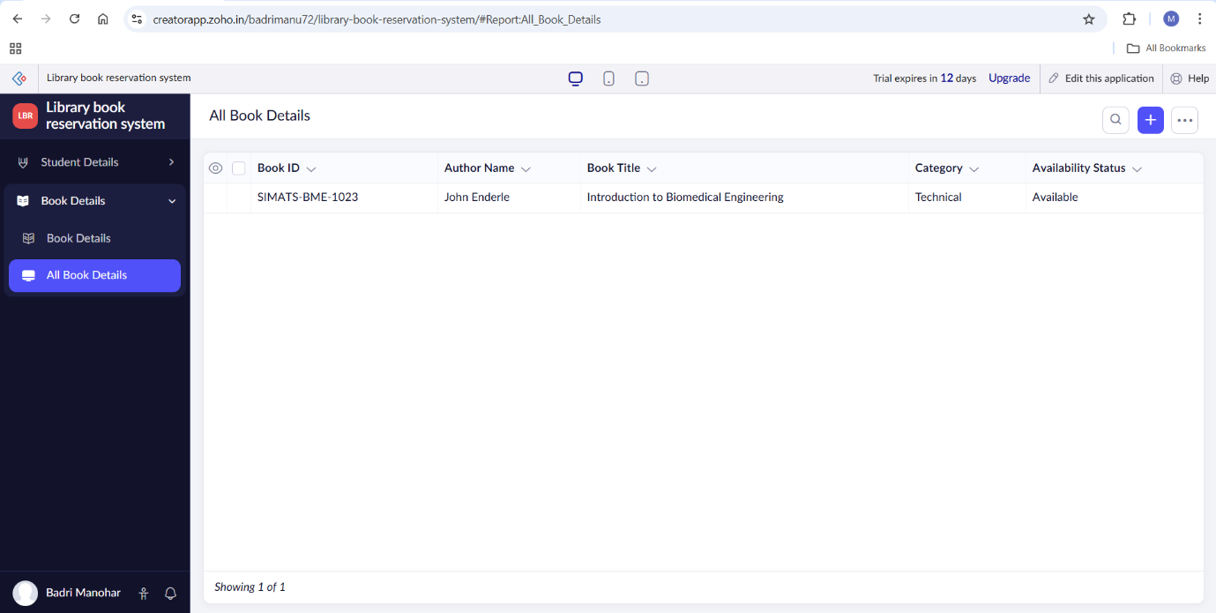
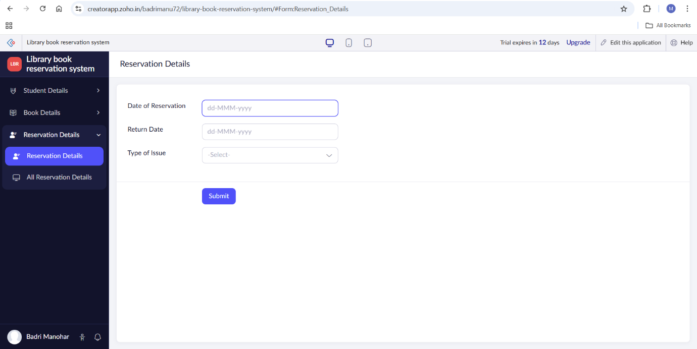
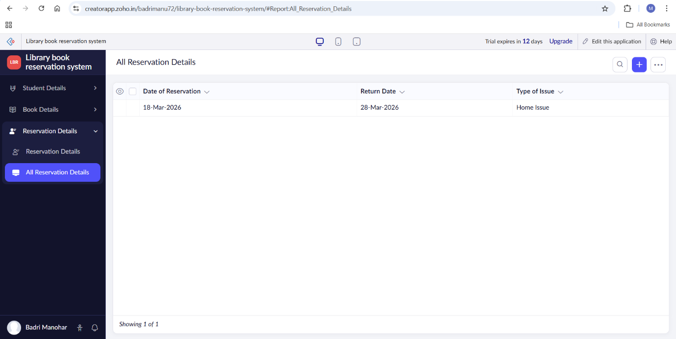

Result
A Library Book Reservation System for SIMATS Library was successfully created using Zoho Creator as a Software as a Service (SaaS) application.The system allows students to reserve books online, view book availability, and manage reservations through a web browser without installing any software.

